

3D Product

Proof Of Process

Headphones

Student Name: Mohammed Alasmawi

Student ID: 201902860

Tutor Name: Khaled Alhasan

Section 2

Bahrain Polytechnic

WM 7002 3D modeling and Animation 1

9th October 2021

Research



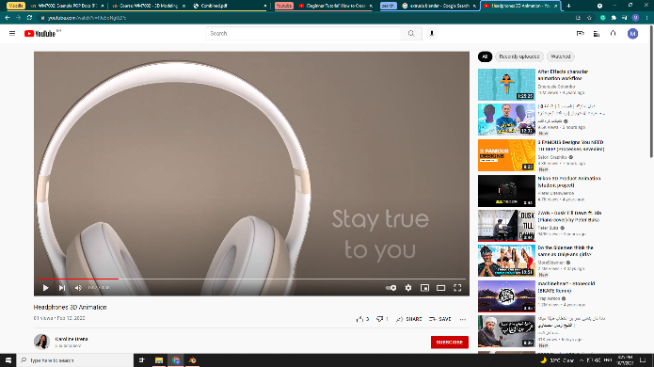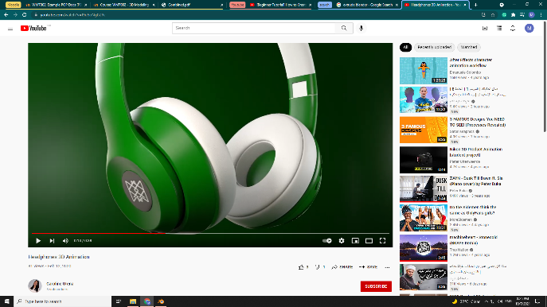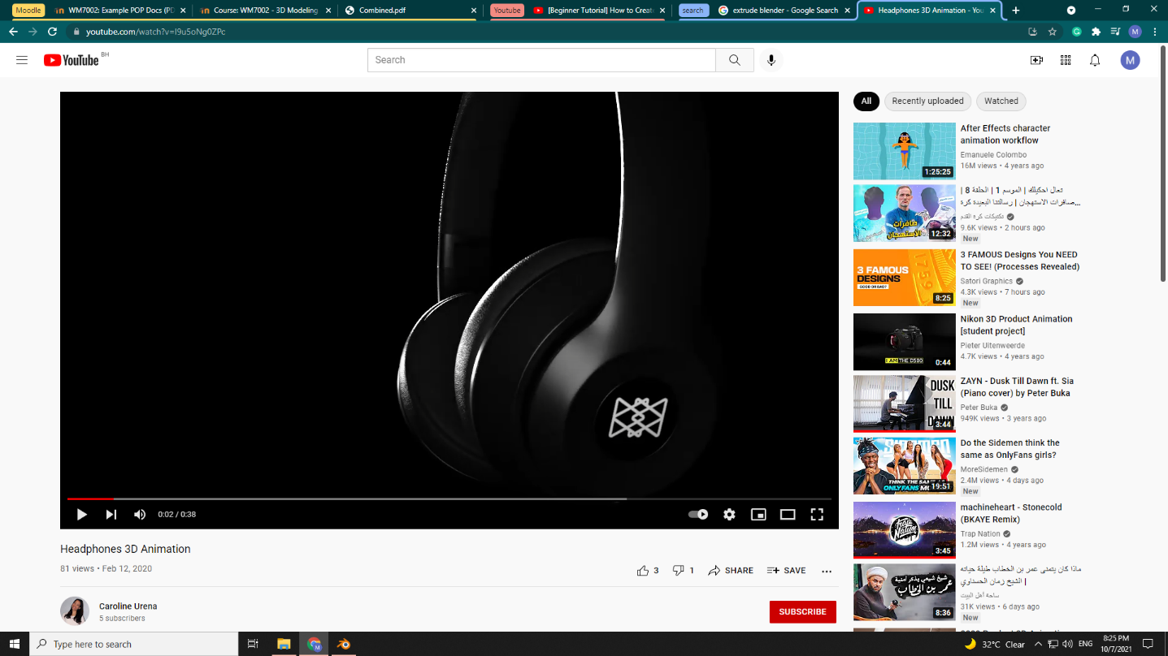Example 1:

I really like this one the change of the color looks amazing the objects look good, moreover the transition between the colored headphones was special.

https://youtu.be/l9u5oNg0ZPc

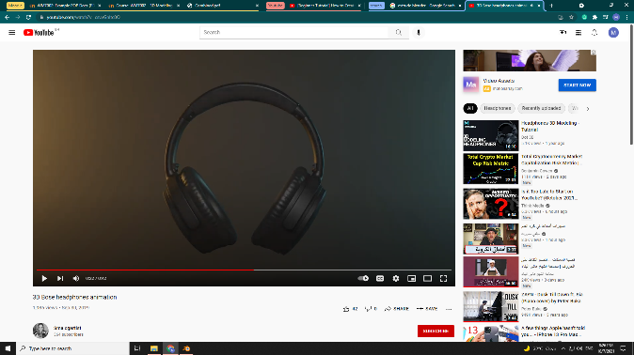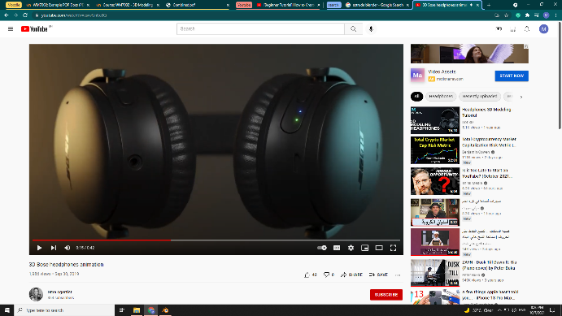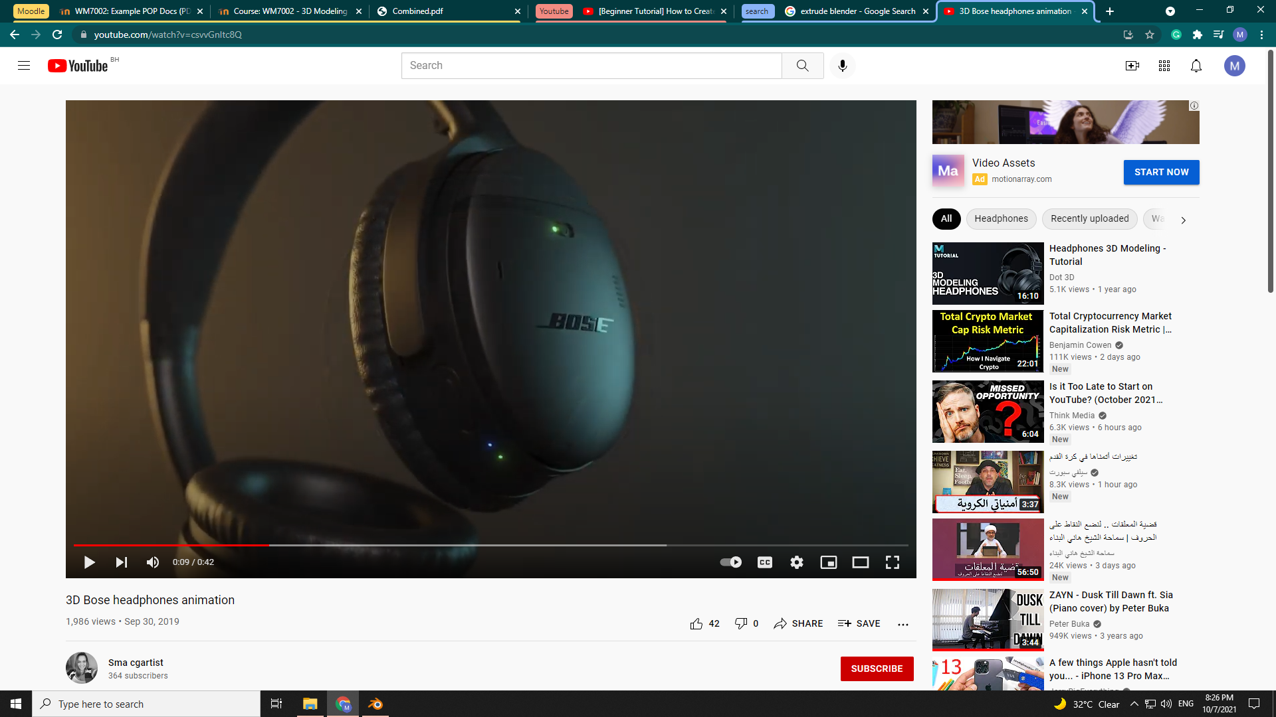Example 2:

In this example the lightening was impressive specially the yellow with this black background, furthermore the blue and green lights in the headphone look very realistic.

https://youtu.be/csvvGnItc8Q

Example 3:

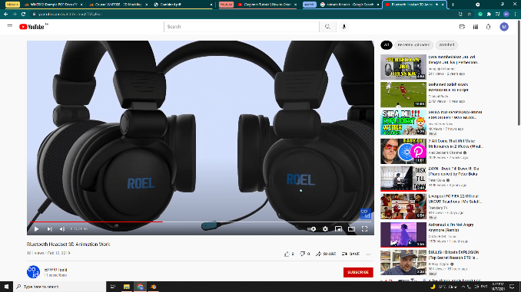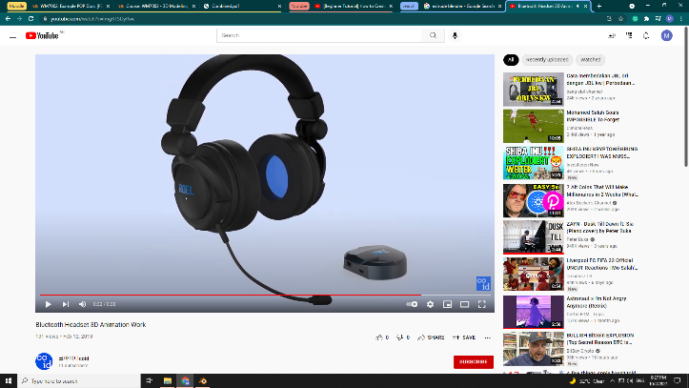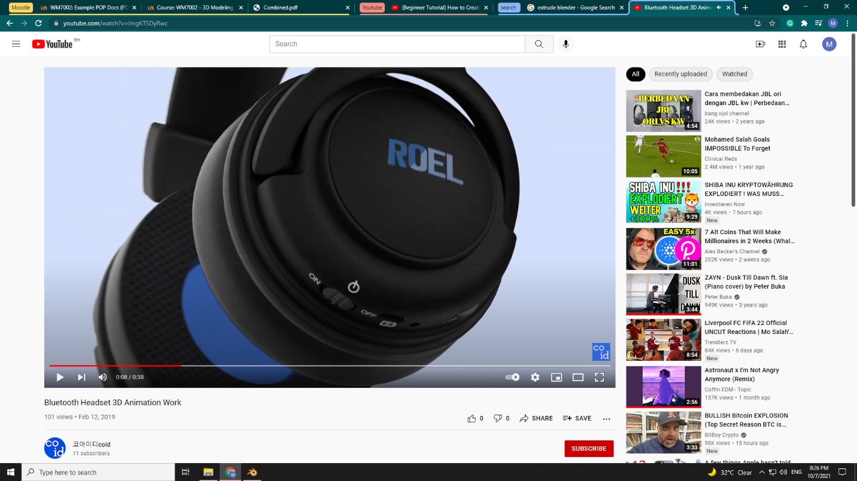

This example shows perfect camera moving over the product (headphones), moreover the details look very good and the duplication of the product added some design in the video.

https://youtu.be/ImgKTSDyRwc

Example 4:

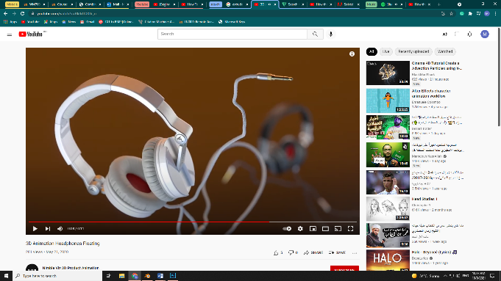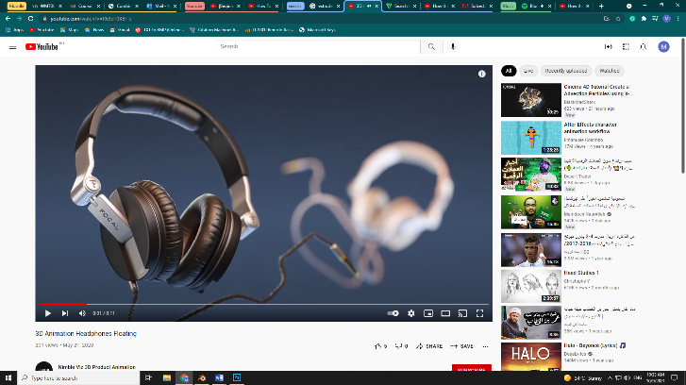

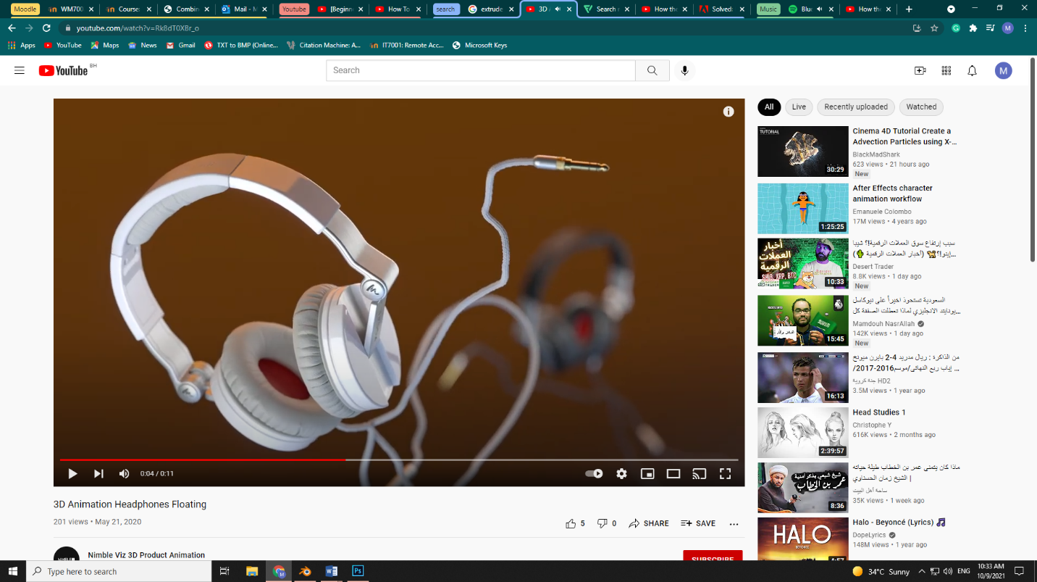

The idea of this example is floating the product (headphones) in the air, the camera movement looks amazing and it looks very realistic.

https://youtu.be/Rk8dT0XBr_o

Example 5:

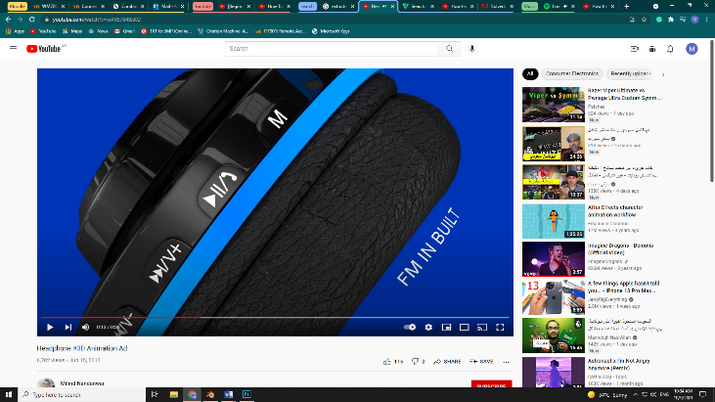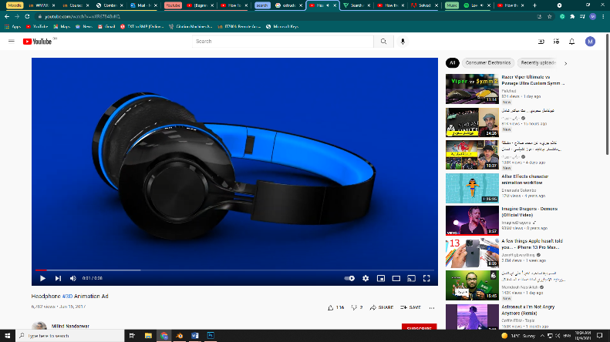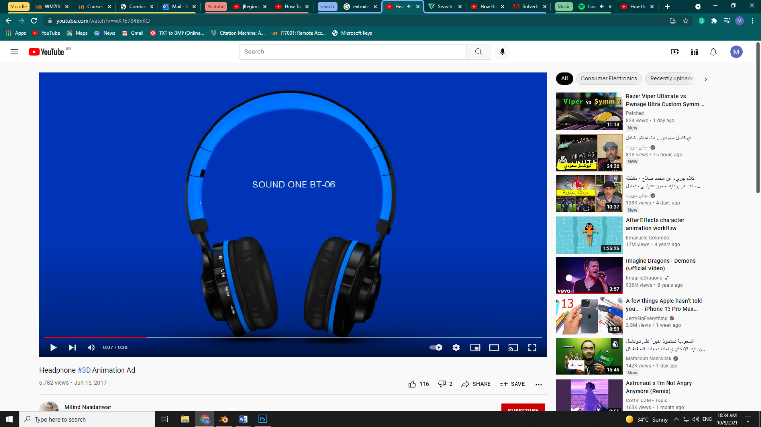

The last example shows a nice match between the background color and the product (headphones) and the camera movement speed move very good moreover it is focus on every part of the headphone.

https://youtu.be/wXR6784BxKQ

Idea Generation



First Idea:

Mostly black headphones

Calm soundtrack

**Background**

**Animation**

**Sound effect**

**Shapes**

**Colors**

1. Add some circles on the headphones
2. Logo shape pass very fast in square shape
3. Fast camera movement
4. Focus on left and right
5. Fade in / out

White background that suits the black headphones

Second Idea:

Blue headphones with some black lines

Water drops with light background

Waterfall sound

**Background**

**Animation**

**Sound effect**

**Shapes**

**Colors**

1. Add some lines under the headphones
2. Fast loop of circles
3. slow camera movement
4. Focus on bottom and up
5. Blur in / out

Third Idea:

1. Fast + slow camera movement
2. Blur in and out

White headphones with some lights or lines

Dark background

Enthusiasm soundtrack

**Background**

**Animation**

**Sound effect**

1. Moving circles
2. Moving eyes

**Shapes**

**Colors**

Concept Development



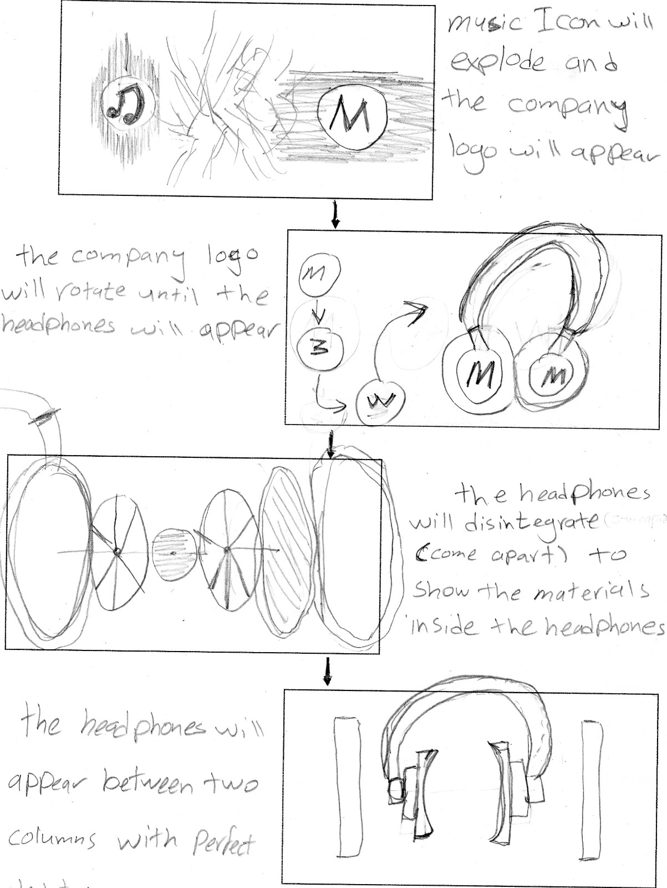First idea:

Second idea:

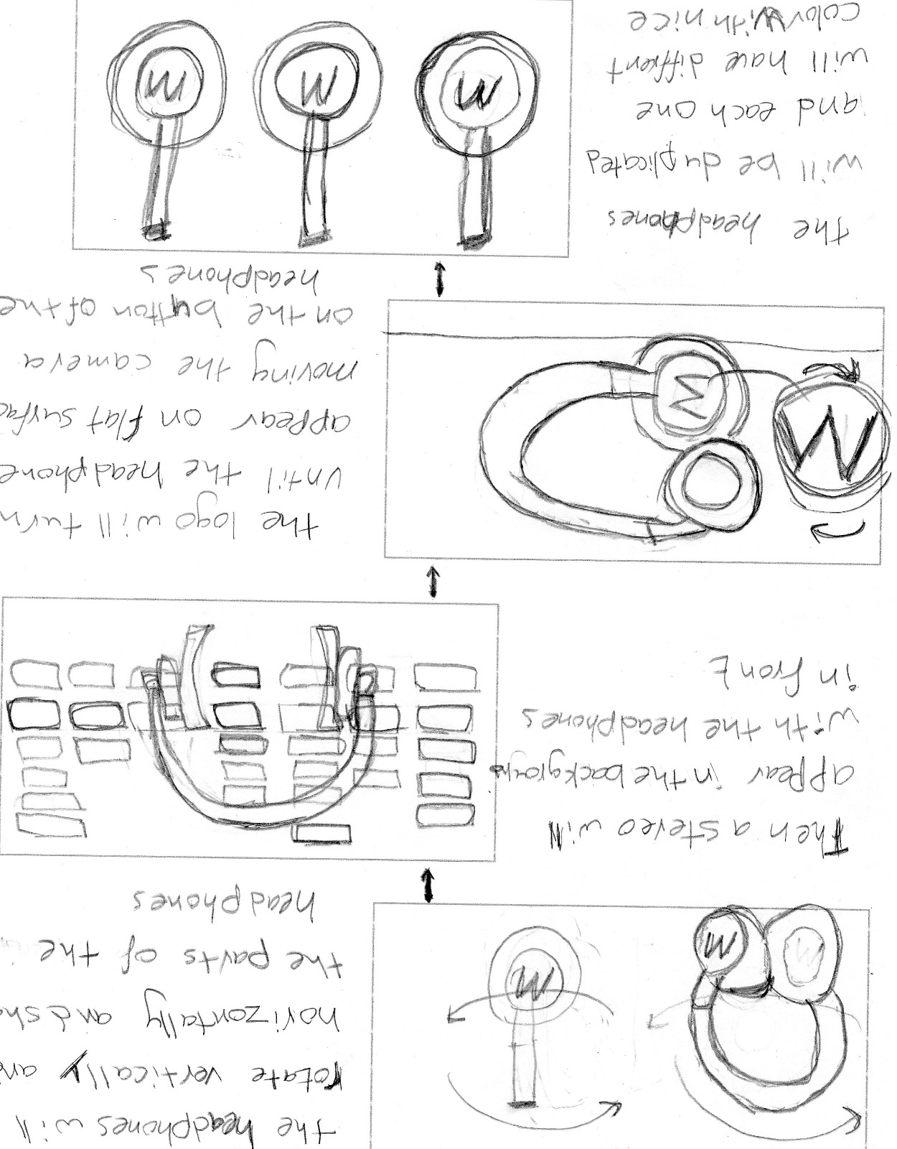

Third idea: 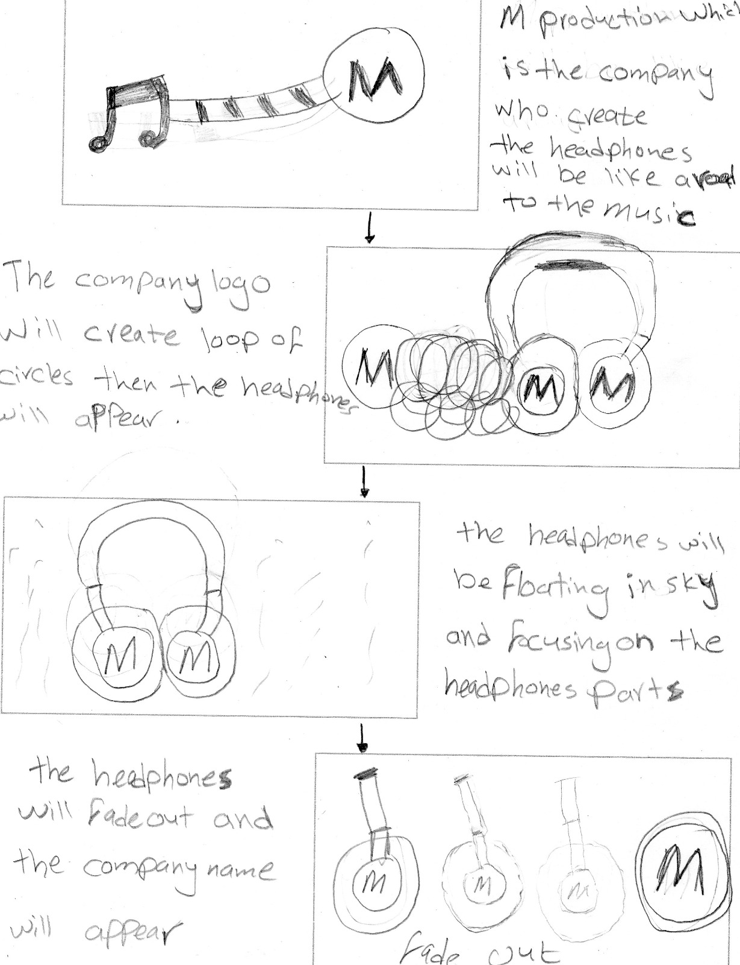

**Pre-Visualisation**



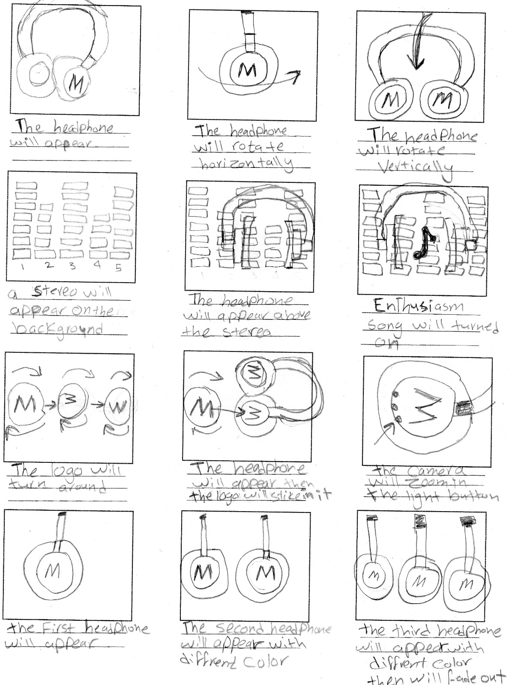

**Treatment**



The main concept for choosing this product which is headphones is that they are useful for many people in a different fields. For example, you will not be able to work and at the same time hold the phone with your hand. Also, if you are driving it’s recommended to use headphones to answer work or emergency phone calls while you are driving. The same thing when you are practicing in the gym. So headphones are very important for our daily life. Furthermore, they are a lot of features such as connecting with Bluetooth or even Wi-Fi. Moreover, you can do some simple stuff such as answering a phone call without touching your phone. Besides, it is also Water-resistant and waterproof so it can handle some sweat and water. Also, the headphone is noise-canceling so if there is a noise around you it will create opposite sound to reduce the noise. Plus, there is a nice feature called (volume-limiting) that have the ability to identify an approximate number of the one who is using the headphone. For example, if a child uses the headphone it will keep the volume at safe levels for him. In addition, it is very felicitous and suits the latest fashion and has multiple colors looks very good in different styles. It is also light and weightless to carry with you in every place.

The product will be presented at the begging and will rotate horizontally and vertically to show the audience the beauty of this headphone then a stereo will appear in the background with moving sound columns. After that, the headphone will appear above it and will turn some enthusiastic music or song. The next scene will start with the logo appearing and turn around or rotate, then the headphone will appear and the logo will be fixed on the headphone, finally zooming on the headphone button. The final scene will display three headphones with nice and different colors that will fade out. The color, the lighting, and the camera moving will be very important to get the best result.